**MMP- ERD Report**

Name: Joshua Youens

Student ID: 2332364

This is the MMP ERD Report. This will contain all the information about the ERDs used within the MMP final product. I will add the tables used within the website, including the ones I used before and added just in the MMP.

**DDL Scripts**

Table name: Signup

|  |  |  |
| --- | --- | --- |
| **Field Name** | **Data Type** | **Constraints** |
| ID | int | Primary Key, Auto increment |
| Name | Varchar(128) | Max 128, Not Null |
| Email | Varchar(255) | Max 255, Not Null |
| Password_hash | Varchar(255) | Max 255, Not Null |
| Event | int | Foreign key, Null |
| Reset_token_hash | varchar(64) |  |
| Reset_token_expires | datetime |  |

DDL Script Screenshot:

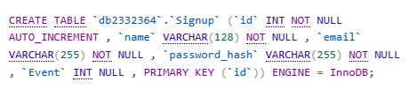

----------------------------------------------------------------------------------------------------------------

Table name: Signup_staff

|  |  |  |
| --- | --- | --- |
| **Field Name** | **Data Type** | **Constraints** |
| ID | int | Primary Key, Auto increment |
| Name | Varchar(128) | Max 128, Not Null |
| Email | Varchar(255) | Max 255, Not Null |
| Password_hash | Varchar(255) | Max 255, Not Null |
| Event | int | Foreign key, Null |
| Reset_token_hash | varchar(64) |  |
| Reset_token_expires | datetime |  |

DDL Script Screenshot:

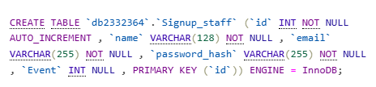

----------------------------------------------------------------------------------------------------------------

Table name: App_events

|  |  |  |
| --- | --- | --- |
| **Field Name** | **Data Type** | **Constraints** |
| Event_ID | int | Primary Key, Auto increment |
| Event | Varchar(50) | Max 50 , Not Null |
| Course | Varchar(100) | Max 100 , Not Null |
| Time | TIME | Not Null |
| Information | Varchar(2000) | Max 2000, not null |
| Room_Number | Text(10) | Max 10, not null |

DDL Script Screenshot:

----------------------------------------------------------------------------------------------------------------

Table name: tips_wlv

|  |  |  |
| --- | --- | --- |
| **Field Name** | **Data Type** | **Constraints** |
| tips_ID | int | Primary Key, Auto increment |
| information | Varchar(100) | Max 100 , Not Null |

DDL Script Screenshot:

----------------------------------------------------------------------------------------------------------------

Table name: Alumni_wlv

|  |  |  |
| --- | --- | --- |
| **Field Name** | **Data Type** | **Constraints** |
| Name | text | Text only, not null |
| Year_Graduated | int | Not Null |
| Degree | text | Text only, Not Null |
| image | VarChar(50) | 50 only |
| id | int |  |

DDL Script Screenshot:

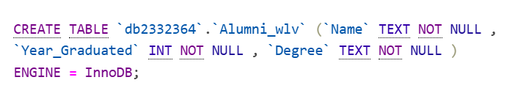

----------------------------------------------------------------------------------------------------------------

Table name: rating

|  |  |  |
| --- | --- | --- |
| **Field Name** | **Data Type** | **Constraints** |
| Num_rate | int |  |
| Comment1 | Text(255) | Max 255, Not Null |
| Comment2 | Text(255) | Max 255, Not Null |

DDL Script Screenshot:

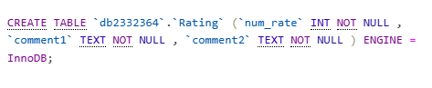

Table name: attendance

|  |  |  |
| --- | --- | --- |
| **Field Name** | **Data Type** | **Constraints** |
| Attendance_id | int | AUTO_INCREMENT, null |
| id | int | null |
| attended | Varchar(3) | null |
| Event_id | int | null |

DDL Script Screenshot:

**The ERD**

Here I will be showing the ERDs I have made for the MMP projects database. I have used Oracle data modeler like in the MVP as it worked very well for what I need it to do. Here are the ERDs:

**Sign_in entity:**

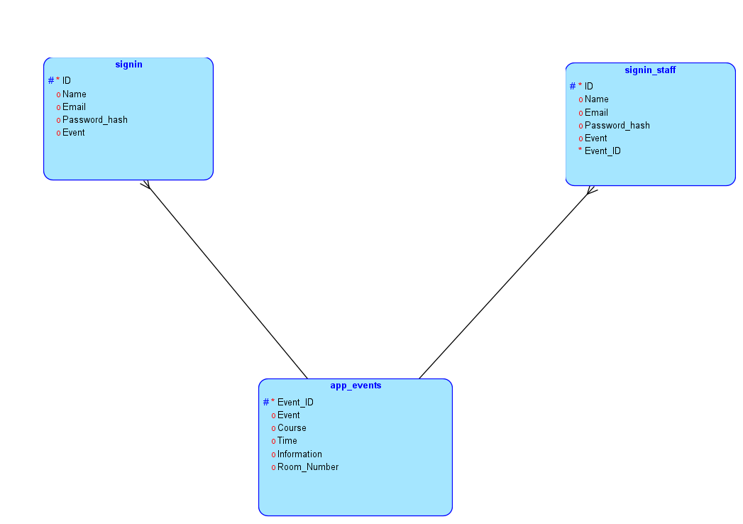

**App_ events entity:**



**Sigin_staff entity:**



**ERD:**



The only entity in the ERD for the tips table:

The only entity in the ERD for the alumni_wlv table:

The only entity in the ERD for the rating table:

